Report on

**Neonatal sleep/wake detection using Deep learning**

**Introduction**

This internship exclusively gave me knowledge and gave me access to work on highly classified medical information and medical dataset, right from collection of data, through annotation and labelling, augmentation as well as training a Deep learning model with the same data collected from NICU. This internship has thought me to do all of it from scratch. Not to mention giving me exclusive access to collect data from NICU from RIT Medical College. Also, providing access to CCU to collect Healthy-pi dst data from elderly. I have learnt more about medical data and biologically inspired optimisation algorithms than ever and also has given me an exposure of working as a research intern and as a professional.

1. Biologically inspired optimisation algorithm.

Bio-inspired computing represents the umbrella of different studies of computer science, mathematics, and biology in the last years. Bio-inspired computing optimization algorithms is an emerging approach which is based on the principles and inspiration of the biological evolution of nature to develop new and robust competing techniques. In the last years, the bio-inspired optimization algorithms are recognized in [machine learning](https://www.sciencedirect.com/topics/computer-science/machine-learning) to address the optimal solutions of complex problems in science and engineering. However, these problems are usually nonlinear and restricted to multiple nonlinear constraints which propose many problems such as time requirements and [high dimensionality](https://www.sciencedirect.com/topics/computer-science/high-dimensionality) to find the optimal solution. To tackle the problems of the traditional optimization algorithms, the recent trends tend to apply bio-inspired optimization algorithms which represent a promising approach for solving complex [optimization problems](https://www.sciencedirect.com/topics/computer-science/optimization-problem). This paper presents state-of-art of nine of recent bio-inspired algorithms, gap analysis, and its applications namely; Genetic Bee Colony (GBC) Algorithm, Fish Swarm Algorithm (FSA), [Cat Swarm Optimization](https://www.sciencedirect.com/topics/computer-science/cat-swarm-optimization) (CSO), [Whale Optimization Algorithm](https://www.sciencedirect.com/topics/computer-science/whale-optimization-algorithm) (WOA), Artificial Algae Algorithm (AAA), Elephant Search Algorithm (ESA), Chicken Swarm Optimization Algorithm (CSOA), Moth flame optimization (MFO), and Grey Wolf Optimization (GWO) algorithm. The previous related works are collected from Scopus databases are presented. Also, we explore some key issues in optimization and some applications for further research. We also analyse in-depth discussions the essence of these algorithms and their connections to self-organization and its applications in different areas of research are presented. As a result, the proposed analysis of these algorithms leads to some key problems that have to be addressed in the future.

In this specifically got to work on Speech signal processing, infant cry signals (GWO) and also facial pattern (2D).

<https://www.sciencedirect.com/science/article/pii/S2314728818300631>

<https://www.sciencedirect.com/science/article/abs/pii/S0957417415007435>

1. SVM & LSVM improvisations

**Support Vector Machine (SVM)**

SVM is a very classical two-classification model, and its working mechanism is to find a suitable hyperplane to segment the collected data samples. The principle of segmentation is to maximize the interval (including hard interval and soft interval), and finalize it into a special quadratic programming problem to solve. The main models are as follows: if the training sample is linearly time-sharing, use the linear separable support vector machine by maximizing the hard interval; if the training sample is approximately linearly time-sharing, use the linear support vector machine by maximizing the soft interval and selecting the appropriate kernel function; if the training sample is linearly non-time-sharing, make it possible to maximize the soft interval and select the appropriate kernel function, with a nonlinear support vector machine . The following is an overview of the main support vector machines.

Linear Separable Support Vector Machine

We first give a training sample set, the most basic idea of the so-called linear separable support vector machine is to find a suitable partition hyperplane in the sample space where the training sample set is *M*, separating the samples of different categories. If a linear function is able to separate samples, these data samples are called linearly separable. So specifically, what is a linear function? we generally think that a linear function is a straight line in a two-dimensional space, a plane in a three-dimensional space, and so on, if spatial dimensions are not considered; such a linear function is collectively called a hyperplane. In a two-dimensional space, for example, we look at a simple example of two-dimensional space. In the example, “*O*” represents positive classes and “*X*” refers to negative classes. Samples are linearly detachable; however, from a graphical point of view, it is clear that not only this straight line can separate samples, but also there are countless lines. The linear separable support vector machine corresponds to lines that can correctly divide the data and have the largest intervals.

Since the maximum interval is sought, it is imperative to calculate the interval in the sample space. In the sample space, we use the following linear equation to describe the division of the hyperplane: where *W* is a normal vector, which determines the direction of the hyperplane and *b* is a displacement, which determines the distance between the hyperplane and the origin. Assume that the hyperplane can correctly classify the training samples; that is, for the training samples, the following formula is satisfied:

The above formula is called the maximum interval hypothesis. It indicates that the sample is a positive sample, expressed as a negative sample. In fact, the specified value of 1 or −1 here is only for the convenience of calculation, in principle can take any constant.

1. Neonatal sleep wake

**Study objectives:**Sleep is an important driver of early brain development. However, sleep is often disturbed in preterm infants admitted to the neonatal intensive care unit (NICU). We aimed to develop an automated algorithm based on routinely measured vital parameters to classify sleep-wake states of preterm infants in real-time at the bedside.

**Data Collection:**

* Devices used: Webcam, Audio Recorder, Laptop, PuTTY application, vitals sensor (spo2, temperature, heart rate), healthy-pi dst.
* Dataset: Video dataset converted to frames which were recorded from NICU, healthy-pi dst data recording from CCU.

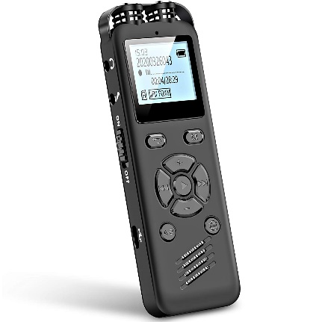

Figure 1.1 Audio Recorder

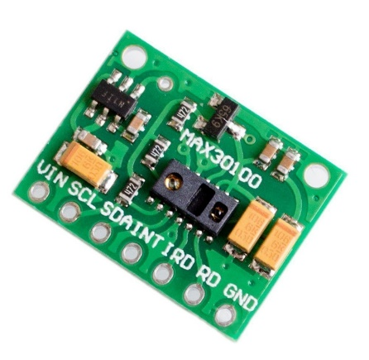

Figure 2.1 Heart rate, spO2 sensor

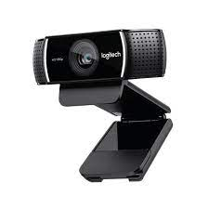

Figure 3 Webcam

Working on Dataset (Pre-Processing)

Extraction of Images/Frames at 30 frames from all collected and previous data from the desktop. Labelling the data using DarkLabel, augmentation and uploading data to Roboflow.

Total of 1000+ images of sleep/awake state of infant were extracted from the videos collected from NICU with 15 images of each baby in sleep/awake state.

Also, I extracted audio recording clips of infants to extract features using acoustics program from matlab.

A software application “PuTTY” was used to record the data from the sensors (the vitals).

The collected dataset of video was converted to frames with images at 30 frames and the dataset was created.

The labelling of data was performed using the Darklabel software with customised settings to match the correct need of our cause.

The annotation and format conversion and augmentation were conducted and executed using roboflow and the augmentation was performed on 3 axis and an augmentation was performed on 1055 images of the infant yielding 3165 images.

Data was split to 70%, 20%, 10% for training, testing and validation of the model respectively.

<https://github.com/darkpgmr/DarkLabel>

<https://roboflow.com/>